Paul Kafka

9/18/2013

Emb. Sys. Des.

**Homework 2**

**Top Level BDF**

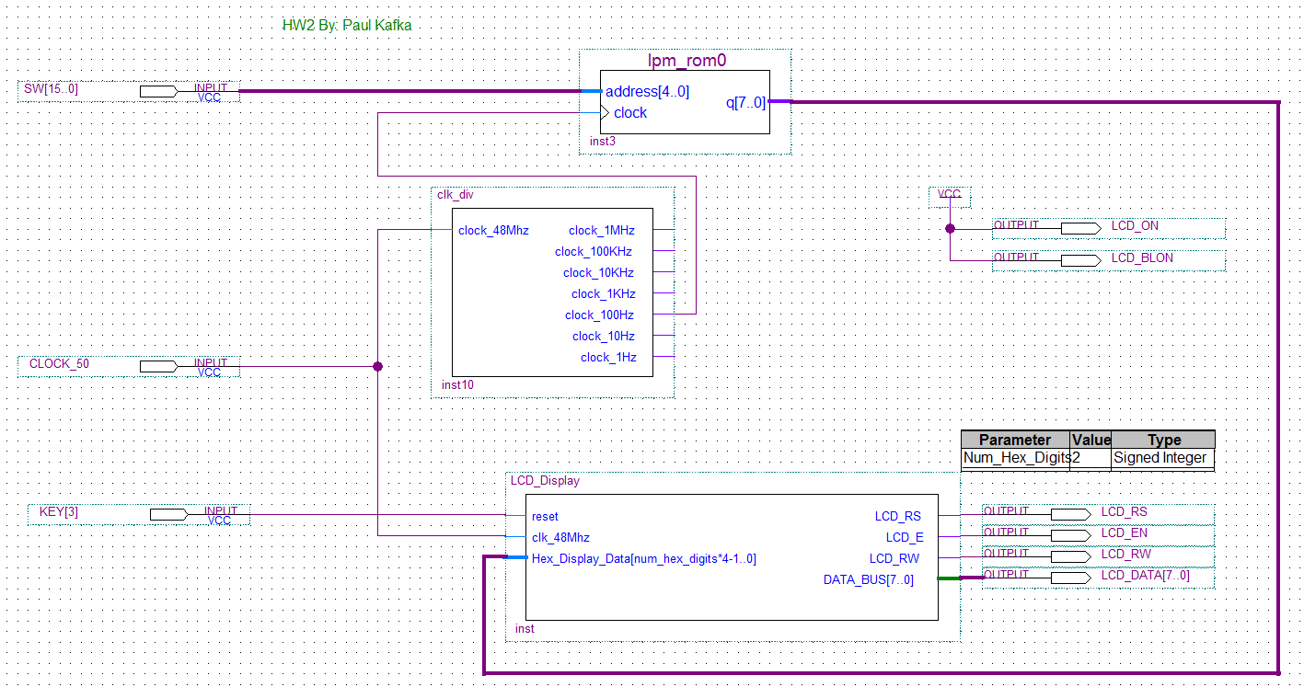

**MIF File**

-- Copyright (C) 1991-2010 Altera Corporation

-- Your use of Altera Corporation's design tools, logic functions

-- and other software and tools, and its AMPP partner logic

-- functions, and any output files from any of the foregoing

-- (including device programming or simulation files), and any

-- associated documentation or information are expressly subject

-- to the terms and conditions of the Altera Program License

-- Subscription Agreement, Altera MegaCore Function License

-- Agreement, or other applicable license agreement, including,

-- without limitation, that your use is for the sole purpose of

-- programming logic devices manufactured by Altera and sold by

-- Altera or its authorized distributors. Please refer to the

-- applicable agreement for further details.

-- Quartus II generated Memory Initialization File (.mif)

WIDTH=8;

DEPTH=256;

ADDRESS_RADIX=UNS;

DATA_RADIX=UNS;

CONTENT BEGIN

[0..255] : 0;

END;